

Information for cleaning staff: Insect Traps

Insect traps have been placed in the building. The traps are white/black pyramids with a flat lid on top.
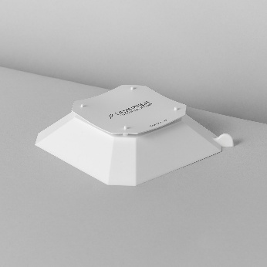 | 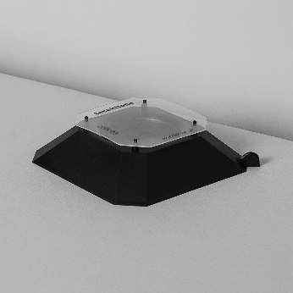 | 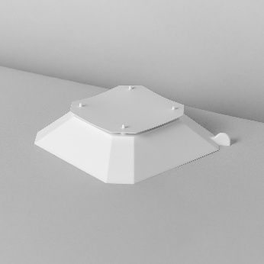 | 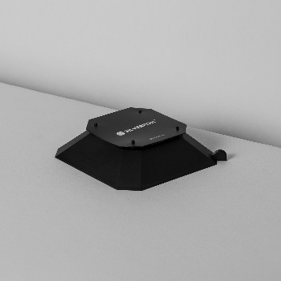

THE TRAPS MUST NOT BE REMOVED!

The traps can be moved during cleaning
They must always be placed flat and preferably against a wall
They can be lifted by the “ear” on the corner of the trap

Dirty traps can be wiped clean with a damp cloth.
The traps can be vacuumed while being held in place, it’s important that they always remain horizontal.

If you have any questions, please contact INSERT NAME at PHONE NUMBER AND/OR EMAIL ADDRESS.

Name
Title
Company

